Technical Specification Document
Project: Basic Banking Application
Version: 1.0
Date: November 04, 2025
Author: Adnan Azad
1. Overview
This document provides a comprehensive technical specification for a Spring Boot MVC REST API with React JS frontend, implementing basic banking services as per the assignment requirements.
The system is designed with scalability, maintainability, security, and auditability in mind. It uses modern Java 21, Spring Boot 3.6, JPA/Hibernate, H2 (dev), JWT authentication, DTO pattern, caching, transaction history, and CI/CD.
2. Design Decisions
Decision | Rationale
Spring Boot + JPA | Rapid development, auto-configuration, embedded DB support
DTO Pattern | Prevent serialization cycles, clean API contracts, security by design
Single Hard-coded Admin User | No user registration needed per spec; simplifies auth
JWT Stateless Authentication | Scalable, no session storage, works with SPAs
Caffeine In-Memory Cache | Fast read performance for inquire operations
Transaction Audit Trail | Full history of deposits/withdrawals
Optimistic Locking | Prevent lost updates in concurrent transactions
React JS Frontend | Modern, component-based, integrates with REST API
Swagger UI | Auto-generated API documentation
Lombok + Records | Reduce boilerplate, immutable DTOs
H2 (dev), PostgreSQL (prod) | Easy local testing, scalable in production
3. Data Models & Entity Relationship Diagram
Customer
├── id: Long (PK, auto)
├── name: String
└── accounts: List<Account> (One-to-Many)

Account
├── number: Long (PK, auto)
├── type: String (e.g., SAVINGS, CURRENT)
├── balance: Big Decimal (default 1.0)
├── status: String (Active/Closed)
├── version: Long (@Version)
└── customer: Customer (Many-to-One)
Transaction
├── id: Long (PK, auto)
├── type: String (DEPOSIT/WITHDRAW)
├── amount: Big Decimal
├── balanceAfter: Big Decimal
├── timestamp: LocalDateTime (@CreatedDate)

└── account: Account (Many-to-One)
ER Diagram
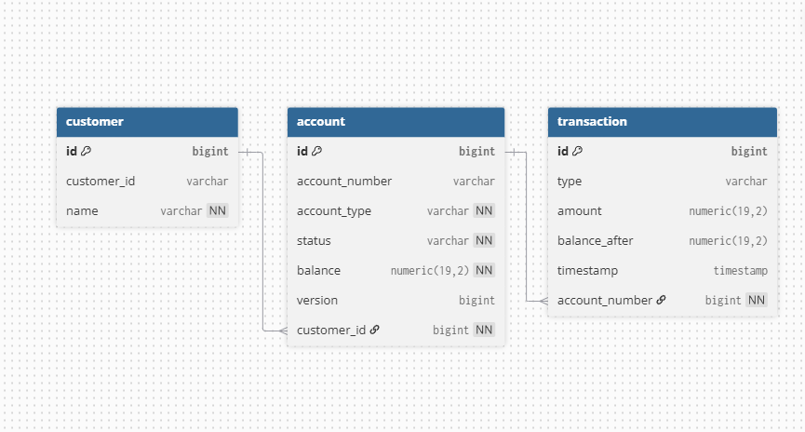
4. Class Diagram (Key Components)
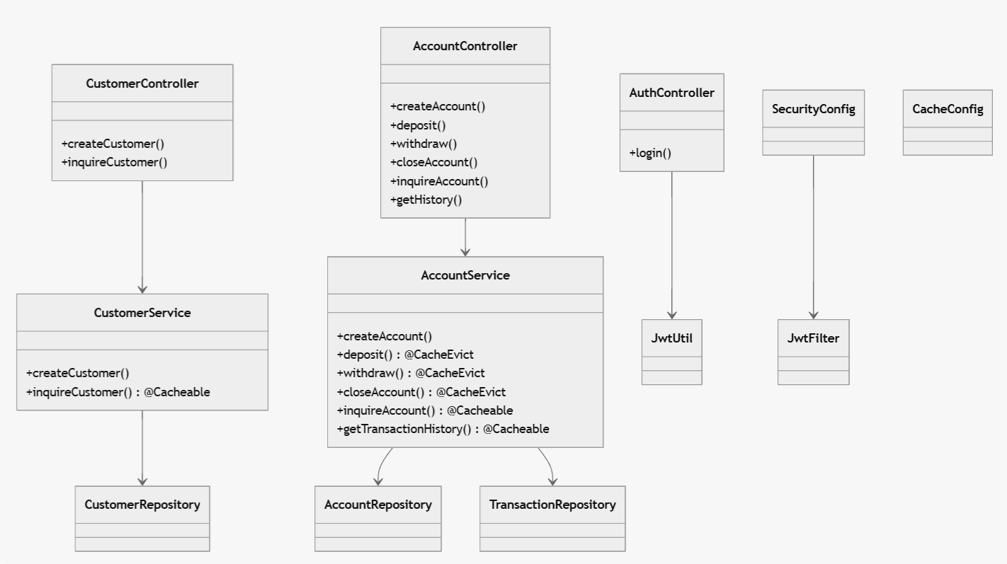
5. Sequence Diagrams
5.1 Create Customer
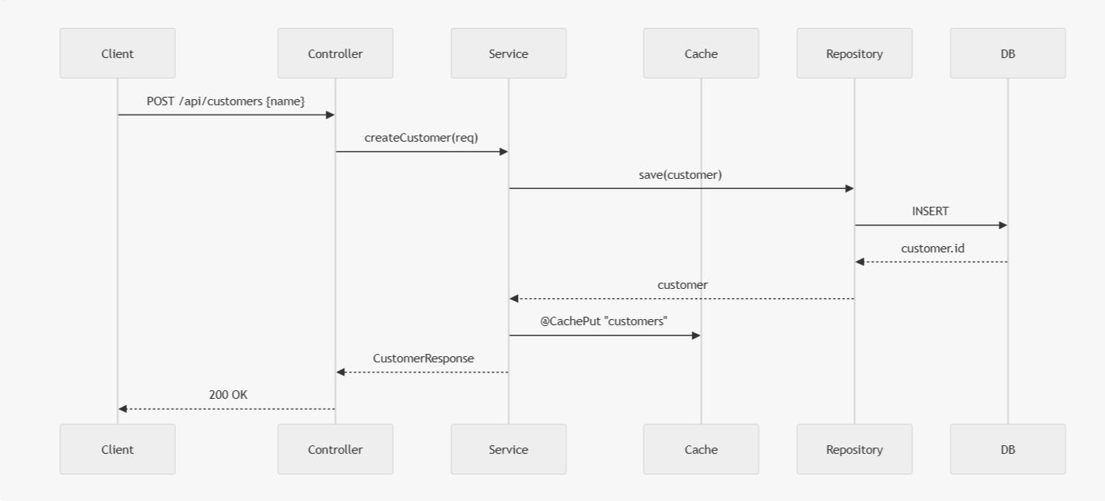
5.2 Deposit with Cache & Audit
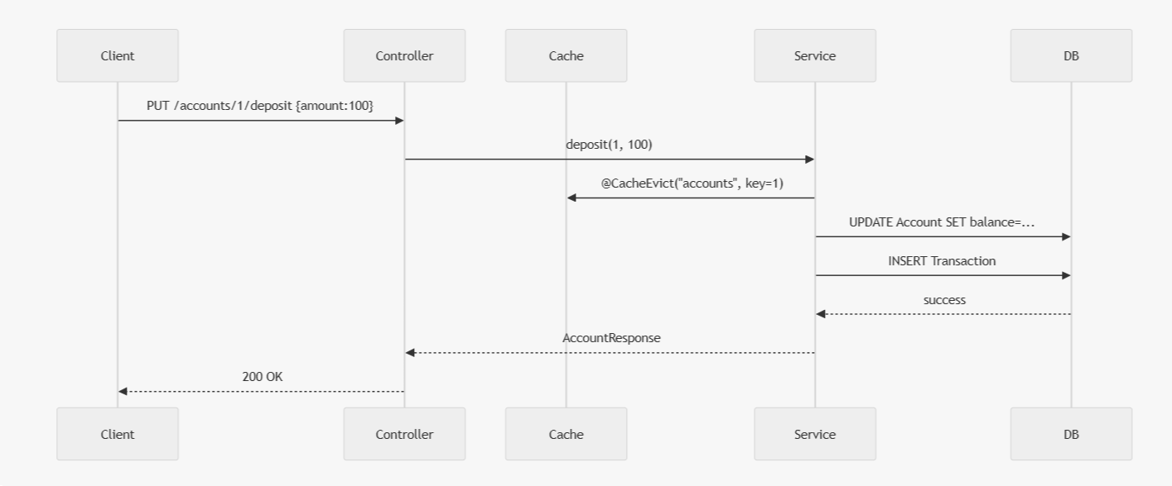
6. API Documentation
Method | Endpoint | Request | Response | Auth
POST | /api/auth/login | {username, password} | {token} | No
POST | /api/customers | {name} | {id, name} | Yes
GET | /api/customers/{customerId  } | — | {id, name} | Yes
GET | /api/customers/all | — | List<CustomerWithAccountsResponse> | Yes
POST | /api/accounts | {customerId  , accountType  } | AccountResponse  DTO | Yes
POST | /api/accounts/deposit | AmountRequest  DTO | AccountResponse  DTO | Yes
POST | /api/accounts/withdraw | AmountRequest  DTO | AccountResponse  DTO | Yes
PUT | /api/accounts/{accountNumber  }/close | accountNumber | AccountResponse  DTO | Yes
POST | /api/accounts/inquire/{accountNumber} | accountNumber | AccountResponse  DTO | Yes
GET | /api/accounts/{accountNumber} | accountNumber | List<TransactionResponse  > | Yes
Swagger UI: http://localhost:8080/swagger-ui/index.html

7. Error Handling Strategies
Exception | HTTP | Message
ResourceNotFoundException | 404 | "Customer not found"
IllegalArgumentException | 400 | "Insufficient funds"
IllegalStateException | 400 | "Account is not active"
OptimisticLockingFailureException | 409 | "Concurrent update detected"
General | 500 | "Internal server error"
Global Handler:
@ControllerAdvice
public class GlobalExceptionHandler { ... }
8. Logging Strategies
- Framework: SLF4J + Logback
- Levels:
  - INFO: Business operations (create, deposit, etc.)
  - WARN: Validation issues
  - ERROR: Exceptions

- Pattern
%d{yyyy-MM-dd HH:mm:ss} %-5level [%thread] %logger{36} - %msg%n
- Example:
2025-11-04 14:30:06 INFO [nio-8080-exec-6] AccountService - Deposited 100.0 to account 1
9. Security Precautions
Layer | Implementation
Authentication | JWT (HS256), 24h expiry
Authorization | All /api/** require valid JWT
Password | BCrypt hashing (admin)
CORS | http://localhost:3000 only
CSRF | Disabled (stateless API)
HTTPS | Enforced via NGINX reverse proxy
Input Validation | DTOs + service checks
Rate Limiting | Ready for Bucket4j
Secrets | JWT_SECRET via environment

10. Testing Strategy

Unit Tests (JUnit 5 + Mockito)
@Test

void createCustomer_success() {

when(repo.save(any())).thenReturn(customer);

var res = service.createCustomer(new CustomerRequest("John"));

assertEquals("John", res.name());
}
Integration Tests (@SpringBootTest + TestRestTemplate):
@Test
void deposit_flow() {
var token = login();
var account = createAccount(token);
var response = restTemplate.exchange(
"/api/accounts/{id}/deposit", PUT, entity(token, "{amount:50}"), AccountResponse.class, account.number());
assertEquals(50.0, response.getBody().balance());
}
Coverage: 80%+ (services)
11. Performance: Handling High Concurrency
Concern | Solution
High Read Load | @Cacheable with Caffeine (10 min TTL)
Cache Invalidation | @CacheEvict on mutations
Concurrent Updates | @Version + optimistic locking
DB Contention | HikariCP (50 connections), indexed account_number
Horizontal Scaling | Stateless JWT → multiple instances
Transaction Volume | Audit via Transaction entity
Monitoring | Spring Boot Actuator + Prometheus
Expected Throughput:
- Inquire: 5000+ RPS (cached)
- Deposit/Withdraw: 1000+ TPS (DB-bound)

12. API Design & Endpoint Structure
- RESTful
- Resource-based: /customers, /accounts
- Versioned: /api/v1/... (future-proof)
- HTTP Methods:
  - POST → create
  - GET → read
  - PUT → update
- Query Params for non-body data (e.g., customerId)
- DTOs for all responses
13. CI/CD & Deployment
GitHub Actions Workflow
Check file in code
Production Deployment (Docker)
Check file in code

14. React UI Integration
- Services: Create/Inquire Customer
- Login Page → stores JWT in localStorage
- Axios Interceptor → adds Authorization: Bearer <token>
- Error Handling → toast notifications
- Validation → form-level (required fields)

15. Conclusion
This system is:
- Fully functional
- Secure (JWT, HTTPS, CORS)
- Scalable (caching, stateless, horizontal)
- Auditable (transaction history)
- Tested (unit + integration)
- Documented (Swagger, this spec)
- Deployable (Docker, CI/CD)
A new developer can:
- Clone repo
- Run ./mvnw spring-boot:run
- Open http://localhost:3000
- Login with admin/adminpass
- Use the banking UI

